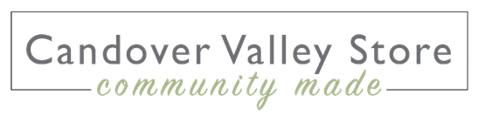

**Join our celebration!**

On Monday 10 June our community store will have been open for five years! Globally and in our little corner of Hampshire, a huge amount has happened in that time and with your amazing support, the fledgling project that we launched in June 2019, has grown into a business that is likely to turn over half a million pounds this year – its best year ever! Please come along on the day to celebrate! The bunting will be flying, a cake will be cut and shared and smiles will abound. We are immensely grateful that our valley community continues to support the store by shopping with us regularly and by giving volunteer hours in a myriad ways. Thank you all and here’s to the next five years! (*Please see the CVCS flyer that has been added to your magazine with details about how to enter our 5th birthday competition and the prizes to be won!)*

**A special day for Dads – Sunday 16 June**

Forget the socks this Father’s Day and get him something he’d really like! You’ll find lots to choose from on the store’s shelves, from Flower Pots beers to a lovely drop of red or a bottle of local sparkling. Then there’s Two Farmers hand-cooked crisps, delicious Old Winchester or Tunworth cheeses or some ChalkStream trout paté, to go with his favourite tipple. And to follow, how about a traybake from The Homemade Brownie Company or a bag of Ourageous Fudge both made within a handful of miles from the store.

**Candover Brook sparkling wine tasting**

English Wine Week 2024 runs from 15-23 June, and on Friday 21 our near neighbours Candover Brook will be showcasing their valley-grown wines in the store. Bottles of the brut and rosé varieties are always available from the store but if you have never had the opportunity to try them, don’t miss this date! What a treat to start the weekend!